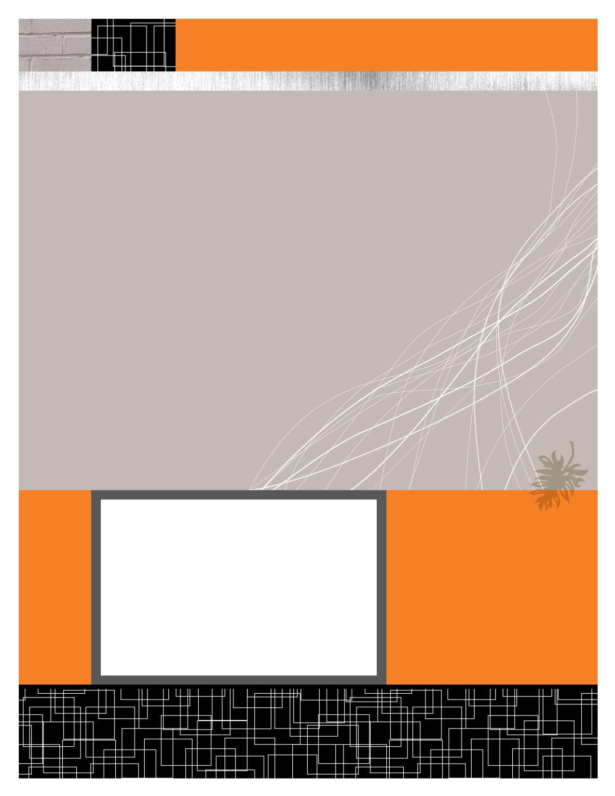

Course Registration Portal

Component Diagrams

March 19, 2012

**Anshul Jain (Y09UC027)**

**Mumal Seth (Y09UC086)**

**Shreya Mundra (Y09UC150)**

**Karan Poddar (Y09UC301)**

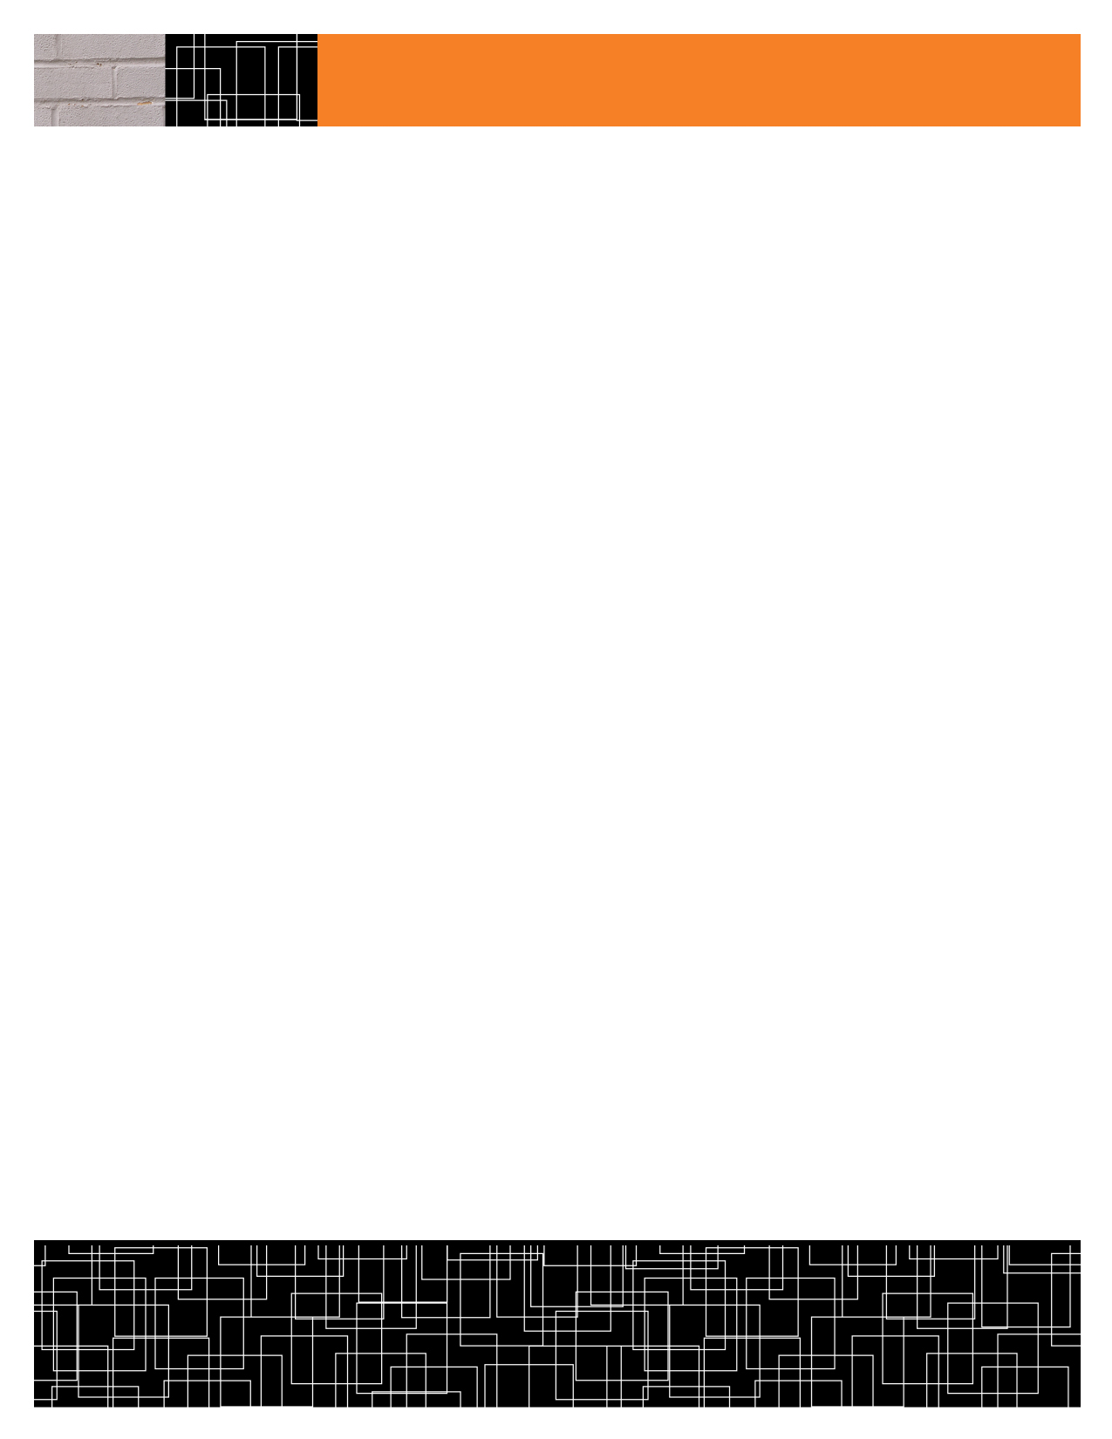

COMPONENT DIAGRAMS

LNMIIT’s COURSE REGISTRATION PORTAL

getLoginDetails()

COURSE REGISTRATION PORTAL

Get-Student-List(Course_Id)

getRegisteredStudents()

Get-Student-Profile(Username) (Course_Id)

getCurriculum()

getStudentList()

CLASS: UserLOGIN

METHODS:

Get-Dean-Profile(Username) [X1]

Get-Professor-Profile(Username) [X2]

Get-Student-Profile(Username) [X3]

Login-Check(Username,Password) [X4]

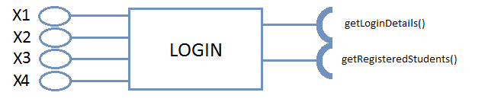



COMPONENT DIAGRAMS

CLASS: FACULTY

METHODS:

Modify-Course-Details(Course_Id) [X1]

View-Student-List(Course_Id) [X2]

Get-Course-Structure(Course_Id) [X3]

X1

**FACULTY**

X2

X3

CLASS: STUDENT

METHODS:

View-Profile() [X1]

View-Application-Status(Application_Id) [X2]

View-Swap-Status(Student_Id,Course_Id) [X3]

View-Course-Details(Course_Id) [X4]

X2

X1

getCurriculum()

X3

**STUDENT**

X4



COMPONENT DIAGRAMS

CLASS: DEAN

METHODS:

get-Student-Profile() [X1]

View-Application() [X2]

Modify-Course-Details(Course_Id) [X3]

X1

getCurriculum()

X2

**DEAN**

X3

getRegisteredStudents()

CLASS: ACADEMIC STAFF

METHODS:

Get-Registered-Students() [X1]

getStudentsList()

**ACADEMIC STAFF**

X3

X2

getRegisteredStudents()

X1



COMPONENT DIAGRAMS

CLASS: COURSE

METHODS:

get-Student-List() [X1]

View-Course-Details(Course_Id) [X2]

Add-Modify-Course-Details(Course_Id) [X3]

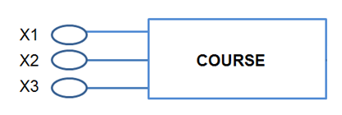

CLASS: REGISTRATION

METHODS:

Create-Application(Student_Id) [X1]

Fill-Registration-Details(Student_Id) [X2]

Drop-Course(Course_Id) [X3]

